

**Capstone Project Report**

**Report 3 – Software Requirement Specification**

– Hanoi, August 2019 –

**Table of Contents**

I. Project Report 3

1. Status Report 3

2. Team Involvements 3

3. Issues/Suggestions 3

II. Software Requirement Specification 4

1. Overall Description 4

1.1 Product Overview 4

1.2 Business Rules 5

2. User Requirements 6

2.1 System Actors 6

2.2 Use Cases 6

3. Functional Requirements 8

3.1 System Functional Overview 8

3.2 <<Feature Name 1>> 10

3.3 <<Feature Name 2>> 10

4. Non-Functional Requirements 11

4.1 External Interfaces 11

4.2 Quality Attributes 12

5. Other Requirements 14

5.1 Appendix1 - Messages List 14

5.2 Appendix2 - … 14

5.3 … 14

# I. Record of Changes

|  |  |  |  |
| --- | --- | --- | --- |
| Date | A* M, D | In charge | Change Description |
|  |  |  |  |
|  |  |  |  |
|  |  |  |  |
|  |  |  |  |
|  |  |  |  |
|  |  |  |  |
|  |  |  |  |
|  |  |  |  |
|  |  |  |  |
|  |  |  |  |
|  |  |  |  |
|  |  |  |  |
|  |  |  |  |

*A - Added M - Modified D - Deleted

# II. Software Requirement Specification

## 1. Product Overview

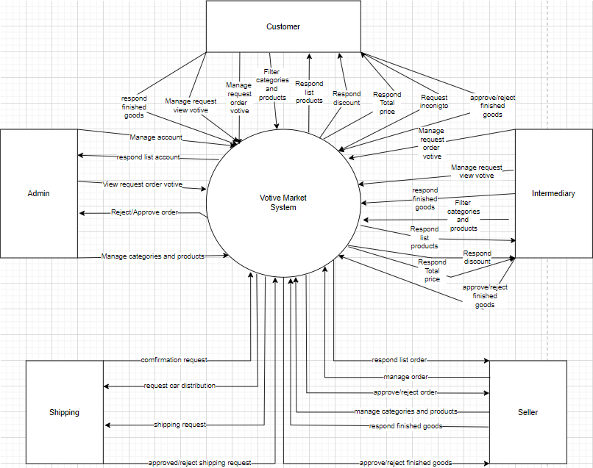

## 2. User Requirements

## 2. User Requirements

### 2.1 Actors

|  |  |  |
| --- | --- | --- |
| **#** | **Actor** | **Description** |
| 1 | Admin | A person who has the highest permission level and is responsible for managing the website. |
| 2 | Guest | The user has not yet registered an account. |
| 3 | Customer | The user that has registered an account. |
| 4 | Intermediary | The role center between client and shop |
| 5 | Seller | Seller is a registered user with an email account and they own a web store |
|  |  |  |
|  |  |  |

### 2.2 Use Cases

#### 2.2.1 Diagram(s)

2.2.1.1 Admin

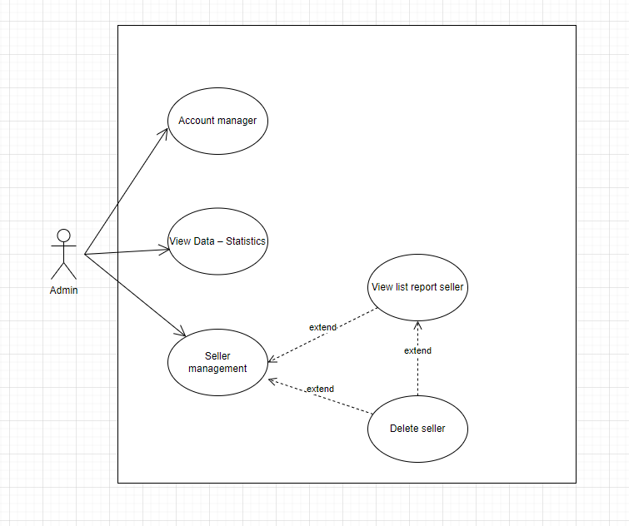

2.2.1.2 Guest

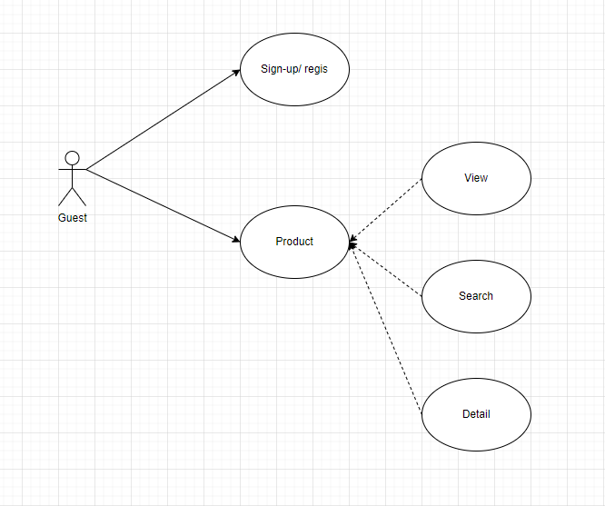

2.2.1.3 Seller

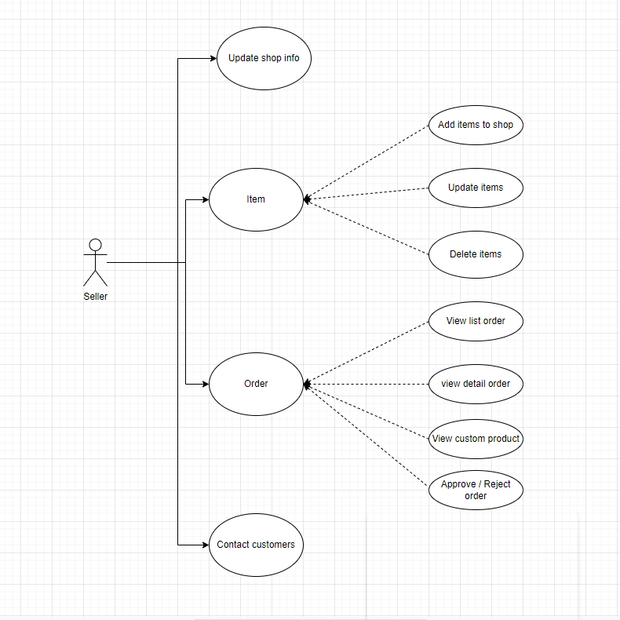

2.2.1.4 User

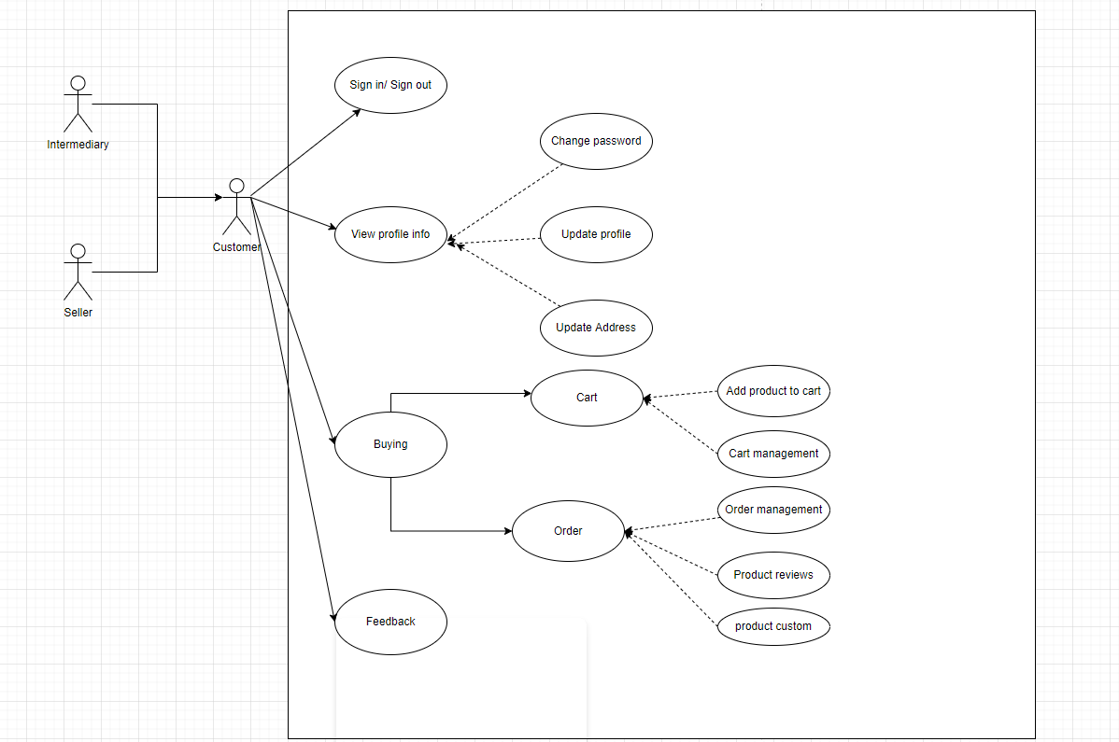

#### 2.2.2 Descriptions

|  |  |  |  |  |
| --- | --- | --- | --- | --- |
| **ID** | **Use Case** | **Primary Actor** |  | **Secondary Actor** |
| 01 | Sign-up | Guest |  | N/A |
| 02 | View Product | Guest |  | Customer |
| 03 | Search Product | Guest |  | Customer |
| 04 | Detail Product | Guest |  | Customer |
| 05 | Sign in | Customer |  | N/A |
| 06 | Sign out | Customer |  | N/A |
| 07 | View profile info | Customer |  | Intermediary |
| 08 | Change password | Customer |  | Intermediary |
| 09 | Update profile | Customer |  | Intermediary |
| 10 | Update address | Customer |  | Intermediary |
| 11 | Add product to cart | Customer |  | Intermediary |
| 12 | Cart management | Customer |  | Intermediary |
| 13 | Order management | Customer |  | Intermediary |
| 14 | Product reviews | Customer |  | Intermediary |
| 15 | Custom product | Customer |  | Intermediary |
| 16 | Feedback information | Customer |  | Intermediary |
| 17 | View dashboard | Admin |  | N/A |
| 18 | Sign in | Admin |  | N/A |
| 19 | Sign out | Admin |  | N/A |
| 20 | Customer management | Admin |  | N/A |
| 21 | Personal profile management | Admin |  | N/A |
| 22 | Account manager | Admin |  | Seller |
| 23 | View Data – Statistics | Admin |  | N/A |
| 24 | Seller management | Admin |  | N/A |
| 25 | Order management | Admin |  | N/A |
| 26 | Manage comments and feedback | Admin |  | N/A |
| 27 | Update shop information | Seller |  | N/A |
| 28 | Add items to the shop | Seller |  | N/A |
| 29 | Update items | Seller |  | N/A |
| 30 | Delete items | Seller |  | N/A |
| 31 | View list order | Seller |  | N/A |
| 32 | View detail order | Seller |  | N/A |
| 33 | Approve order | Seller |  | N/A |
| 34 | Reject order | Seller |  | N/A |
| 35 | Contact customers | Seller |  | N/A |
| 36 | View custom product | Seller |  | N/A |
| 37 | Sign in | Intermediary |  | N/A |
| 38 | Sign out | Intermediary |  | N/A |
|  |  |  |  |  |
|  |  |  |  |  |
|  |  |  |  |  |
|  |  |  |  |  |
|  |  |  |  |  |
|  |  |  |  |  |

**UC-01**

|  |  |  |  |
| --- | --- | --- | --- |
| ID and Name | Sign up | | |
| Created By: | Bùi Anh Tuấn | Date Created: | 3/6/2022 |
| Primary Actor: | Guest | Secondary Actors: | N/A |
| Description: | Sign up for an account on the system. | | |
| Trigger: | Users want to register an account. | | |
| Pre-conditions: | 1. User does not have an account 2. No user account yet 3. The user's device is already connected to the internet when logging in | | |
| Post-conditions: | When the normal process completes successfully, a new account will be created with the desired user role and saved to the database. | | |
| Normal flow: | 1. Go to Home Page. 2. Click “Đăng ký” 3. System displays “Sign Up” form. 4. Input username, email, password, confirm password, select account type 5. Clicks “Đăng ký” button. 6. System displays a toast success message. 7. Redirect to Login Screen. | | |
| Alternative Flows: | N/A | | |
| Exceptions: | The system displays an error message when:   1. Not input all fields in the “Sign Up” form 2. Email existed 3. Cannot connect to the server | | |
| Priority: | High | | |
| Frequency of User: | High | | |
| Business Rules: | N/A | | |
| Other Information: | N/A | | |
| Assumptions: | N/A | | |

**UC-02**

|  |  |  |  |
| --- | --- | --- | --- |
| ID and Name | View Product | | |
| Created By: | Bùi Anh Tuấn | Date Created: | 3/6/2022 |
| Primary Actor: | Guest | Secondary Actors: | Customer |
| Description: | View all product | | |
| Trigger: | The users want to view product | | |
| Pre-conditions: | N/A | | |
| Post-conditions: | N/A | | |
| Normal flow: | 1. Go to Home Page | | |
| Alternative Flows: | N/A | | |
| Exceptions: | The system displays an error message when:   1. Cannot connect to the server | | |
| Priority: | Normal | | |
| Frequency of User: | Normal | | |
| Business Rules: | N/A | | |
| Other Information: | N/A | | |
| Assumptions: | N/A | | |

## 3. Functional Requirements

### 3.1 System Functional Overview

*[Provide functionality overview of software system: screen flow, screen descriptions, system user roles, screen authorization, non-screen functions, ERD]*

#### 3.1.1 Screens Flow

*format for different visuality purpose]*

#### 3.1.2 Screen Descriptions

*[Provide the descriptions for the screens in the Screens Flow above]*

|  |  |  |  |
| --- | --- | --- | --- |
| **#** | **Feature** | **Screen** | **Description** |
| 1 | Order Meals | Create Order | <<Screen Brief description>> |
| 2 | Order Meals | Change Order |  |
| 3 | .. |  |  |

#### 3.1.3 Screen Authorization

*[Provide the system roles authorization to the system features (down to screens, and event to the screen activities if applicable) in the table form as below – replace Role1, Role2,… with your specific system user role names]*

|  |  |  |  |  |
| --- | --- | --- | --- | --- |
| **Screen** | **Role-Name1** | **Role-Name2** | **Role-Name3** | **…** |
| <<Screen Name1>> | X |  | X | X |
| <<Screen Activity>> |  |  | X | X |
| <<Screen Name2>> | X |  | X |  |
| Query All Data | X |  |  |  |
| Query Own Data |  |  | X |  |
| Query Managed Data |  |  | X |  |
| Add New Data |  |  | X | X |
| Update All Data |  |  |  | X |
| Update Own Data |  |  |  | X |
| Update Managed Data |  |  |  | X |
| Delete Data |  |  |  |  |
| … |  |  |  |  |

#### 3.1.4 Non-Screen Functions

*[Provide the descriptions for the non-screen system functions, i.e batch/cron job, service, API, etc.]*

|  |  |  |  |
| --- | --- | --- | --- |
| **#** | **Feature** | **System Function** | **Description** |
| 1 | <<Feature Name>> | <<Function Name1>> | <<Function Name1 Description>> |
| 2 | … |  |  |

#### 3.1.5 Entity Relationship Diagram

*[Provide the entity relationship diagram and the entity descriptions in the table format as below]*

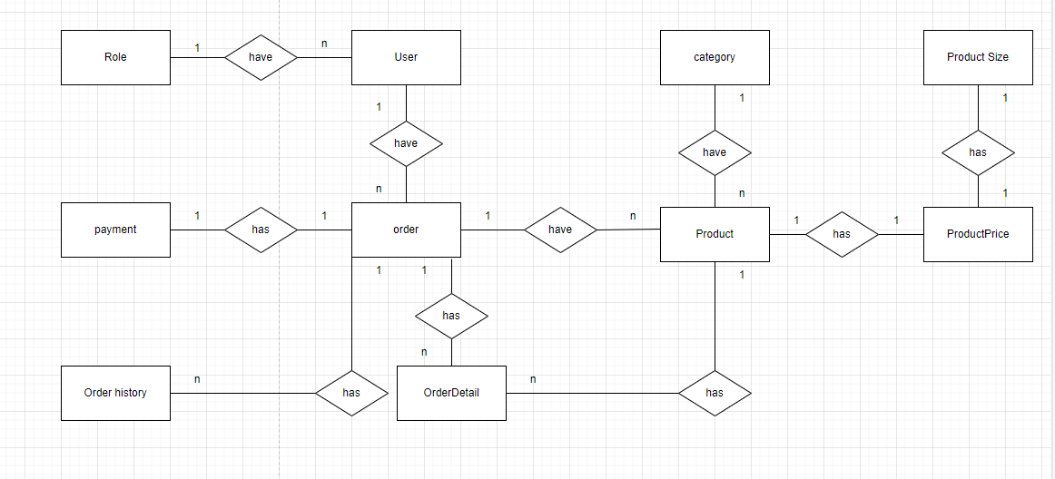

**Entities Description**

|  |  |  |
| --- | --- | --- |
| **#** | **Entity** | **Description** |
| 1 | User | That use interface |
| 2 | Role | Seller,admin,user …. |
| 3 | Order | That view order |
| 4 | Order Detail | Information of order |
| 5 | Order history | That use view history |
| 6 | Payment | That use payment |
| 7 | Product | Product information |
| 8 | Product Price | Price of product |
| 9 | Product Size | Size of product |
| 10 | Category | Type product |

### 3.2 <<Feature Name 1>>

#### 3.2.1 <<Function Name 1>>

*[A function can be a screen or a non-screen function (listed in the part 3.1.5 above). In this part, you need to provide the details on the related function, focus on mentioning below information*

* *Function trigger: how this function is triggered (navigation path, a timing frequency, etc.*
* *Function description: actors/roles, purpose, interface, data processing, etc.*
* *Screen layout: mock-up prototype of the screen, sample below is for Manage Products screen*

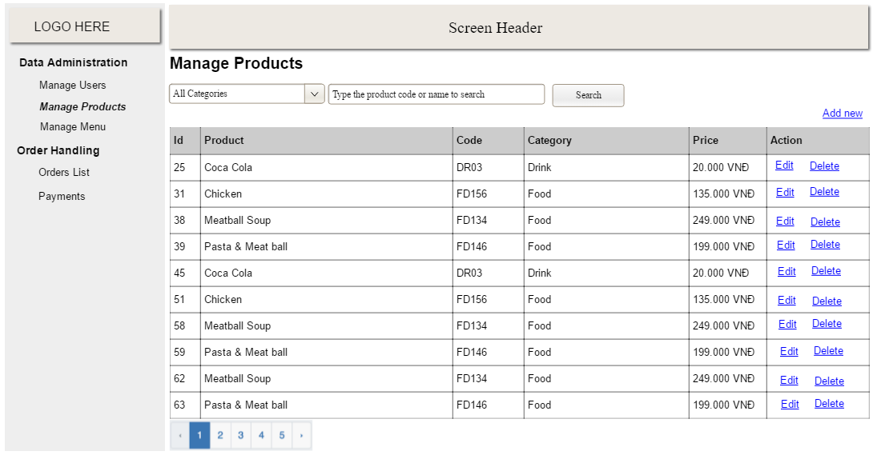

* *Function Details: provide explanation for the data, validation, business rules, functionalities (for both normal cases and abnormal cases), etc. of the function so that the reader can image how it work.*

*]*

#### 3.2.2 <<Function Name 2>>

…

### 3.3 <<Feature Name 2>>

…

## 4. Non-Functional Requirements

4.1 External Interfaces

#### 4.1.1.User interfaces

**UI-1**: The web application display shall conform to the user and provide a friendly interface.

**UI-2**: The font size is easy to distinguish where is the title, where is the content.

**UI-3**: Consistent interface: font size, font, color, the logo must be in sync.

**UI-4**: The web application will support responsive screens on mobile, tablet, and desktop Quality Attributes

#### 4.2.1 Usability

**USA-1**: The steps and flows are short and easy to understand so that users can interact with the application without training.

**USA-2**: The user interface is clean, friendly, and consistent from the layout, component to the

button, text field.

**USA-3**: The input action is flexible with both keyboard and mouse.

**USA-4**: Error and warning messages are simple.

#### 4.2.2 Reliability

#### 4.2.3 Performance

* Reduce as less as possible query to database in loop
* Resource utilization: use very few computer resources such as ram, memory, CPU.

#### 4.2.4 Dependence

##### 4.2.4.1. Security

- Only the Admin account has access to system management.

- The system does not allow users who are not FPT University students to register for an account on the system but with other roles as recruiters and sellers.

- The recruiter role will not be able to sell and the seller role will not be able to post job vacancies.

- The system uses spring security to classify the user type for the system.

##### 4.2.4.2 Safety

- The password of the account is encrypted since creating a moment.

- The password should be hidden in the client.

#### 4.2.5 Supportability

- The account's password must be MD5 encrypted

- Named according to the Coding Convention

#### 4.2.6 Design Constraints

The back-end programming language is .NET

Front-end programming language is ReactJS

## 5. Requirement Appendix

### 5.1 Business Rules

|  |  |
| --- | --- |
| **ID** | **Description** |
|  | The email address must be valid |
|  | Password must be at least 8 characters in length |
|  | Password must be encrypted |
|  | When registering or changing a password, the user must enter the new password twice |
|  | A guest cannot register with a username and email that has already been registered |
|  | User cannot update their email once it has been registered |
|  | When changing a password, the new password must not be the same as the current password |
|  | Format of date must be “dd/mm/yyyy” |
|  | When an account is registered, the user must choose their roles |
|  | Email is unique and cannot be duplicated in the database |
|  | Format of money must be “10.000” |
|  | Format DateTime of comment restaurant must be “dd-MMM-yyyy HH:mm:ss” |
|  | User must provide their email and password when logging into the website |
|  | When updating the profile, the phone number is unique and cannot be duplicated in the database |
|  | The deadline of request when creating or updating must be in the future |
|  | After creating or re-opening a request to find a job or recruitment, the status of the request is PENDING |
|  | Students can repost a request find a job when the request’s status is COMPLETE or EXPIRED |
|  | A recruiter can repost request recruitment when the request’s status is COMPLETE or EXPIRED |
|  | Students can only apply for job postings when the job posting's status is APPROVED |
|  | A recruiter can only hire workers when the find job posting's status is APPROVED |
|  | When deleting posts that are not " APPROVED" status, the posts on the homepage are not deleted |
|  | When add, update or report, the blanks must be filled in completely. |

### 5.2 Common Requirements

### 5.3 Application Messages List

|  |  |  |  |  |
| --- | --- | --- | --- | --- |
| **#** | **Message code** | **Message Type** | **Context** | **Content** |
|  | MSG01 | In red, Toast Message | Wrong account | Email hoặc mật khẩu không chính xác. |
|  | MSG02 | In green, Toast Message | Logout success | Đăng xuất thành công. |
|  | MSG03 | Toast Message | Notify actions | Bạn phải hoàn thành ít nhất một đơn hàng trước khi đánh giá cửa hàng. |
|  | MSG04 | Toast Message | Notify actions | Không thẻ xóa thẻ này vì thẻ này đang được sử dụng. |
|  | MSG05 | Toast Message | Notify actions | Cập nhật mật khẩu mới thành công! |
|  | MSG06 | Toast Message | Notify actions | Có lỗi xảy ra. Vui lòng thử lại. |
|  | MSG07 | Toast Message | Notify actions | Mật khẩu cũ không đúng! |
|  | MSG08 | Toast Message | Notify actions | Mật khẩu xác nhận không giống với mật khẩu mới! |